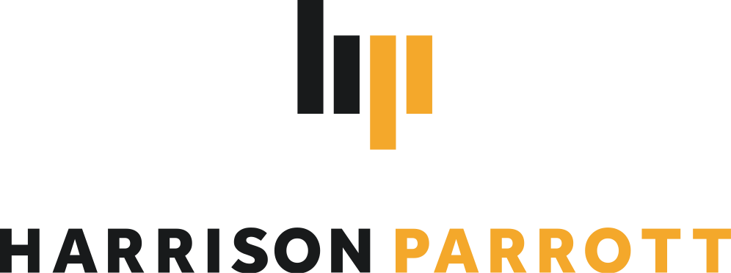

Goldmund Quartet

# String Quartet

The Goldmund Quartet is known to feature “exquisite playing” and “such multi-layered homogeneity*”* (*Süddeutsche Zeitung*) in its interpretations of the great classical and modern works of the quartet literature. Its inwardness, the unbelievably fine intonation and the phrases worked out down to the smallest detail inspire audiences worldwide.

As evident from their 2024/25 season calendar, the Quartet is now counted amongst the leading string quartets of the younger generation worldwide. Highlights include another substantial tour of the US taking in Montréal, Indianapolis and Memphis and a tour of Japan on the occasion of the Nippon Foundation’s 50th anniversary at Suntory Hall with Ray Chen, Camille Thomas, Maria Dueñas and as soloists with Tokyo Symphony Orchestra. The ensemble will debut at prestigious festivals such as Schubertiade Hohenems and HarzClassixFestival, appear on Cyprus and in Split, at Teatro Liceu de Salamanca and in Florence in the renowned series of the Amici della Musica Firenze. Returns will lead them to the Schleswig-Holstein Music Festival, Elbphilharmonie Hamburg, Oraniensteiner Konzerte and the Bodensee Festival. The Goldmund Quartet presents their own chamber music festival at Kloster Irsee in May 2025. Additionally, the Goldmund Academy will be held for the very first time offering guidance for young string quartets and providing a platform for emerging talent.

Following the 2020 release on Berlin Classics of *Travel Diaries* - the Quartet's third album including works by Wolfgang Rihm, Ana Sokolovic, Fazil Say and Dobrinka Tabakova - the Goldmund Quartet published an album dedicated to Franz Schubert and released a limited vinyl release of *Prisma* in 2023. The latter featured contemporary works by Arvo Pärt, Philip Glass and Uno Helmersson alongside two newly commissioned pieces by Pascal Schumacher and Sophia Jani. Collaborations with composers such as Kaan Bulak, Jörg Widmann and others give evidence of their dedication to commissioning and performing contemporary music. These efforts alongside educational projects are supported by the Friends of Goldmund Quartett e.V. The next CD release, of an album of works by Felix Mendelssohn, is planned for Spring 2025.

Winners of the 2018 International Wigmore Hall String Competition and the 2018 Melbourne International Chamber Music Competition, the Quartet was named Rising Stars by the European Concert Hall Organisation for 2019/20. Since 2019, they have been performing Antonio Stradivari's Paganini Quartet, provided by the Nippon Music Foundation. In addition, the Quartet was awarded the Jürgen Ponto Foundation Music Prize in March 2020 and the Freiherr von Waltershausen Prize in December 2020. In 2016, the Quartet won the Bavarian Arts Promotion and the ARD Competition’s Karl Klinger prizes.

The Goldmund Quartet has performed alongside artists such as Jörg Widmann, Ksenija Sidorova, Sabine Meyer, Pablo Ferrández, Nino Gvetadze, Noa Wildschut, Martynas Levickis, Maximilian Hornung, Elisbeth Brauß, Christian Gerhaher and Fazil Say.

In addition to studies at the Hochschule für Musik und Theater in Munich and with members of the Alban Berg Quartet, including Günter Pichler at the Escuela Superior de Música Reina Sofia and the Artemis Quartet in Berlin, master classes and studies with members of the Hagen, Borodin, Belcea, Ysaye and Cherubini Quartets, Ferenc Rados, Eberhard Feltz and Alfred Brendel gave the Quartet important musical impulses.