For release: June 5, 2024

The Cleveland Orchestra announces the promotion of Daniel Reith to associate conductor and the extension of his contract as music director of The Cleveland Orchestra Youth Orchestra through the 2024-25 season
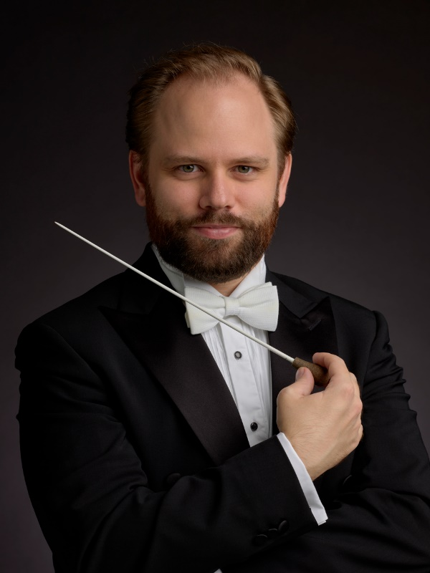
(©Roger Mastroianni)

CLEVELAND — The Cleveland Orchestra announced the promotion of Assistant Conductor Daniel Reith to the position of Associate Conductor with immediate effect. Reith, who also serves as the music director of The Cleveland Orchestra Youth Orchestra (COYO), will assume this role through the end of the 2024-25 season following a one-year contract extension.

Reith was appointed by Cleveland Orchestra Music Director Franz Welser-Möst and joined the Orchestra’s conducting staff at the beginning of the 2022-23 season at Severance Music Center. Since then, he has conducted The Cleveland Orchestra in dozens of performances, including education concerts in Cleveland and Miami, the Family Concert series, the annual Martin Luther King Jr. Celebration Concert, and the Orchestra’s very first sensory-friendly concerts.

“Building on the success of the last two seasons, Franz Welser-Möst has offered Daniel a contract extension to remain with The Cleveland Orchestra as Associate Conductor for one more season,” said Ilya Gidalevich, the Orchestra’s Vice President of Artistic Planning. “Daniel has become an invaluable asset to our conducting staff, and we’re looking forward to his continued work with the musicians of The Cleveland Orchestra as well as his leadership of The Cleveland Orchestra Youth Orchestra.”

As music director of COYO, Reith oversees artistic planning and coaching sessions, selects musicians, and leads rehearsals and performances of the ensemble, which consists of about 100 middle and high school-aged musicians.

“I’m honored to extend my time in Cleveland with the tremendously brilliant musicians of The Cleveland Orchestra under the direction of acclaimed Music Director Franz Welser-Möst,” Reith said. “It’s also been such a pleasure and an enriching experience working with The Cleveland Orchestra Youth Orchestra. I’ve enjoyed introducing these students to new classical works, helping them refine their skills and understanding of playing in a large ensemble, and deepening their connection to this wonderful music we perform.”

COYO wrapped up its three-concert 2023-24 season with a performance on May 3 featuring Tchaikovsky’s Symphony No. 4, Lalo’s Cello Concerto, and Valerie Coleman’s Umoja, and has recently returned from a music exchange and side-by-side performance with the Toronto Symphony Youth Orchestra.

Reith occupies the Elizabeth Ring and William Gwinn Mather Endowed Chair.

About Daniel Reith
German conductor Daniel Reith is the Associate Conductor of The Cleveland Orchestra and the Music Director of The Cleveland Orchestra Youth Orchestra (COYO). The 2024-25 season marks his third year with both ensembles.
Based in Cleveland, Ohio, Reith is showing great promise on the American orchestral scene. He made his Cleveland Orchestra subscription debut in February 2023 after stepping in for Finnish conductor Klaus Mäkelä at very short notice. He also covered for Music Director Franz Welser-Möst to lead the Orchestra as part of the first annual Mandel Opera & Humanities festival concert in May 2023.
In addition to his coaching and conducting duties with COYO, Reith leads the Orchestra’s education concerts in Cleveland and Miami, as well as family and community concerts throughout the season.
Reith is also an established talent in Scandinavia and has performed with the Oslo and Bergen philharmonic orchestras, Stavanger, Kristiansand and Trondheim symphony orchestras, Norwegian Radio Orchestra, and Norwegian Armed Forces. Having served as Assistant Conductor at the Norwegian Opera for a production of Orpheus in the Underworld, Reith returned to Oslo this season for a symphonic concert with the Norwegian Opera Orchestra, conducting Strauss’s Also Sprach Zarathustra.
Well versed in a wide range of repertoire, Reith has a special interest in the German repertoire, including the classical core repertoire and more particularly works from the late romantic period. He is strongly dedicated to reviving unknown music from this time and sharing it with today’s audiences.
Reith is a winner of the prestigious Opptakt competition, Talent Norway’s program for fostering young conductors, as well as one of their former conducting program participants. He holds degrees in conducting, piano and music theory from the Norwegian Academy of Music, Hochschule für Musik und Darstellende Kunst Frankfurt and Hochschule für Musik Freiburg.
For more information about Daniel Reith, visit harrisonparrott.com/artists/daniel-reith.

About The Cleveland Orchestra Youth Orchestra
The Cleveland Orchestra Youth Orchestra (COYO) is a full symphonic ensemble composed of approximately 100 young musicians drawn from 35 communities in seven counties across Northern Ohio. Founded in 1986 by Jahja Ling (then resident conductor of The Cleveland Orchestra), COYO provides serious young music students of middle and high school age with a unique pre-professional orchestral training experience.

Among the acclaimed artists to work with COYO are Cleveland Orchestra Music Director Franz Welser- Möst, Marin Alsop, Pierre Boulez, Stephane Deneve, Christoph von Dohnanyi, Giancarlo Guerrero, Witold Lutosławski, Yo-Yo Ma, Gil Shaham, Michael Tilson Thomas, and Antoni Wit. The ensemble has been featured on three international tours.

Generously supported by the Geoffrey and Sarah Gund endowment, The Cleveland Orchestra Youth Orchestra is part of a suite of Cleveland Orchestra programs designed to nurture aspiring young musicians, which also includes the Cleveland Orchestra Youth Chorus, the Cleveland Orchestra Children’s Chorus and Preparatory Chorus, and the Crescendo and Music Mentors pathways initiatives for students in Cleveland schools.

In addition, and with the support of many generous individual, foundation, corporate, and governmental funding partners, the Orchestra’s full range of education and community programs reach more than 100,000 young people and adults annually, helping to foster a lifelong relationship with music by removing barriers to participation, advocating for and helping to facilitate equitable access to comprehensive music education in schools, and harnessing the life-changing power in service to the community.

For more information, please visit: clevelandorchestrayouthorchestra.com/.

# # #
Media Contact:
Jen Steer, jsteer@clevelandorchestra.com, 216-231-7637

